# Application Testing And Debugging Report

# Testing 360 Home Décor(<https://360homedecor.uk/>)

1. Ui bug on Home page. Link is (<https://360homedecor.uk/home>)

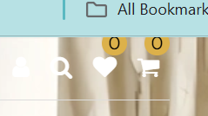

1. On Home Page -> Subscribe to our newsletter! In CheckBox to Subscribe Email (console.log is not commented in home.html file).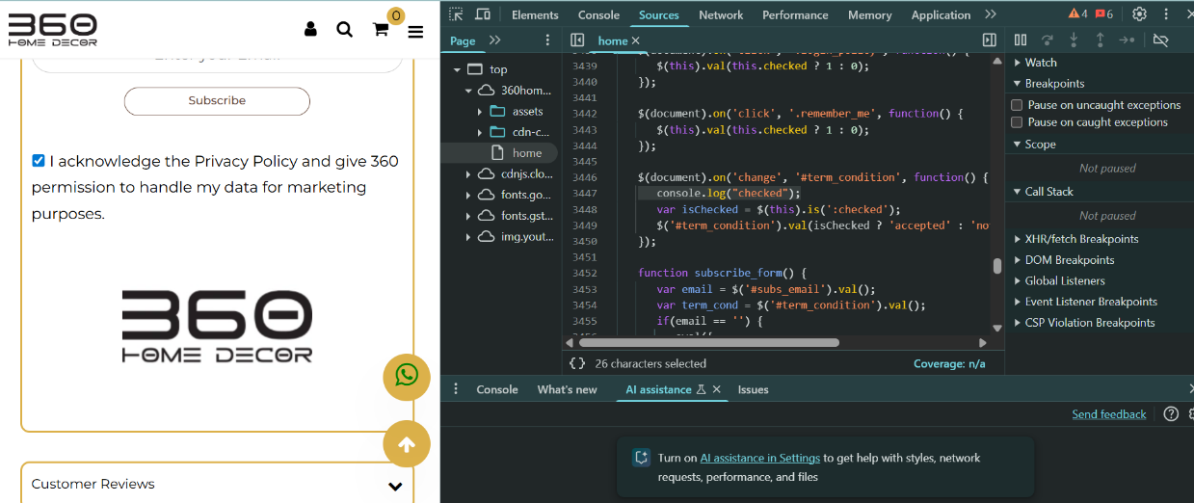
2. Email Validation Not working while Subscribing at Home page(<https://360homedecor.uk/home>). Like Example it take ([123@Wronggmail.com](mailto:123@Wronggmail.com)) then it will subscribe Successfully.

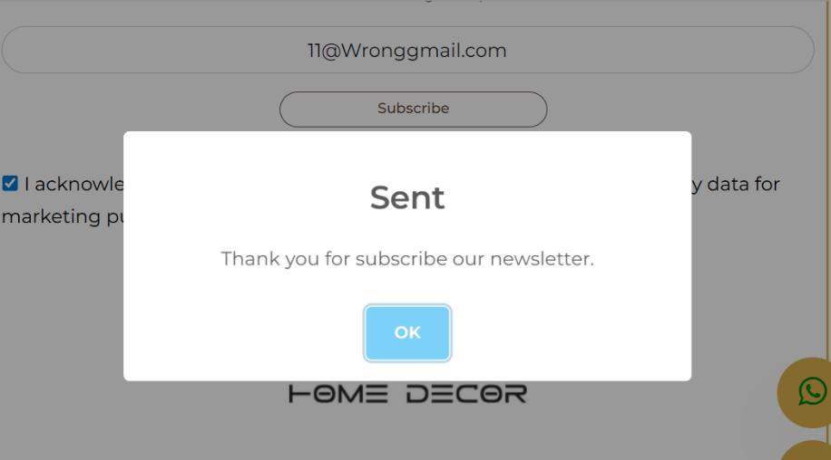

1. No Email Validation is there while we are Sign up/login to the website. It Login Successfully and create account with fake email like([ajay@FirstGmail.com](mailto:ajay@FirstGmail.com)). Also In Name field it take number, and in password field it accept any size of password like(12,134,89).

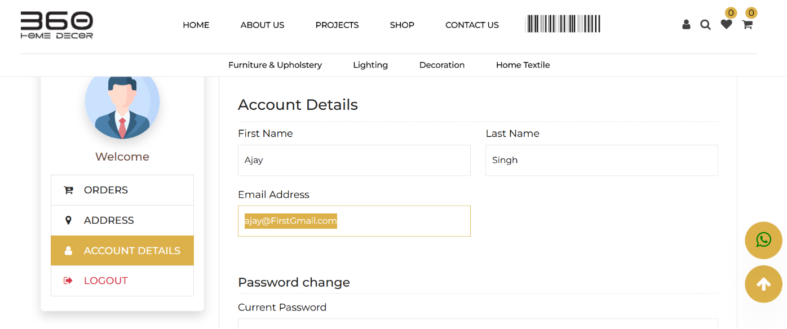

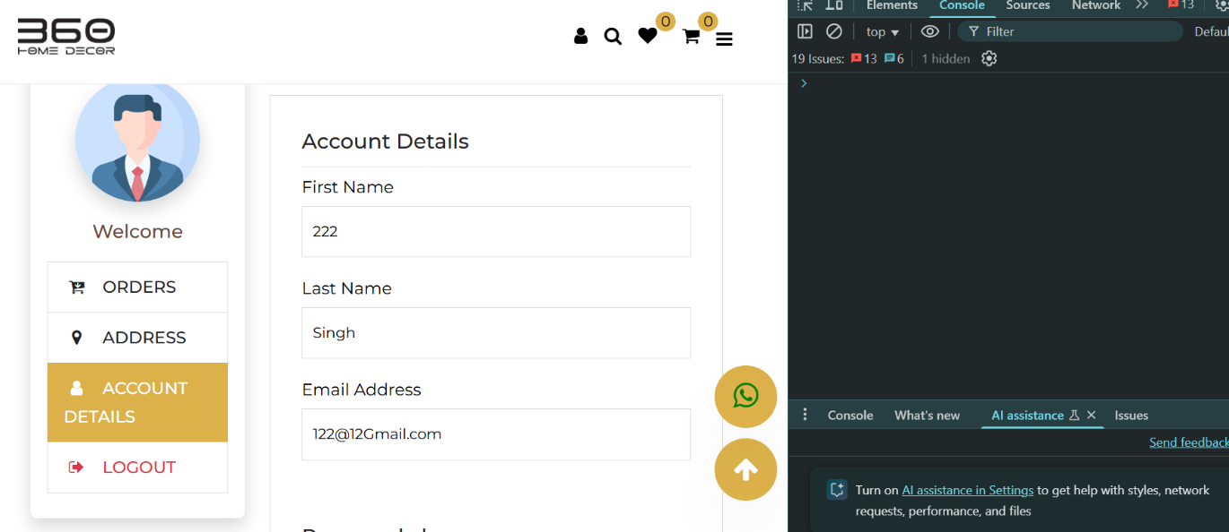

5.On My Account(<https://360homedecor.uk/my-account>) Billing Address post data request is not working (show error code 500 Internal Server Error).

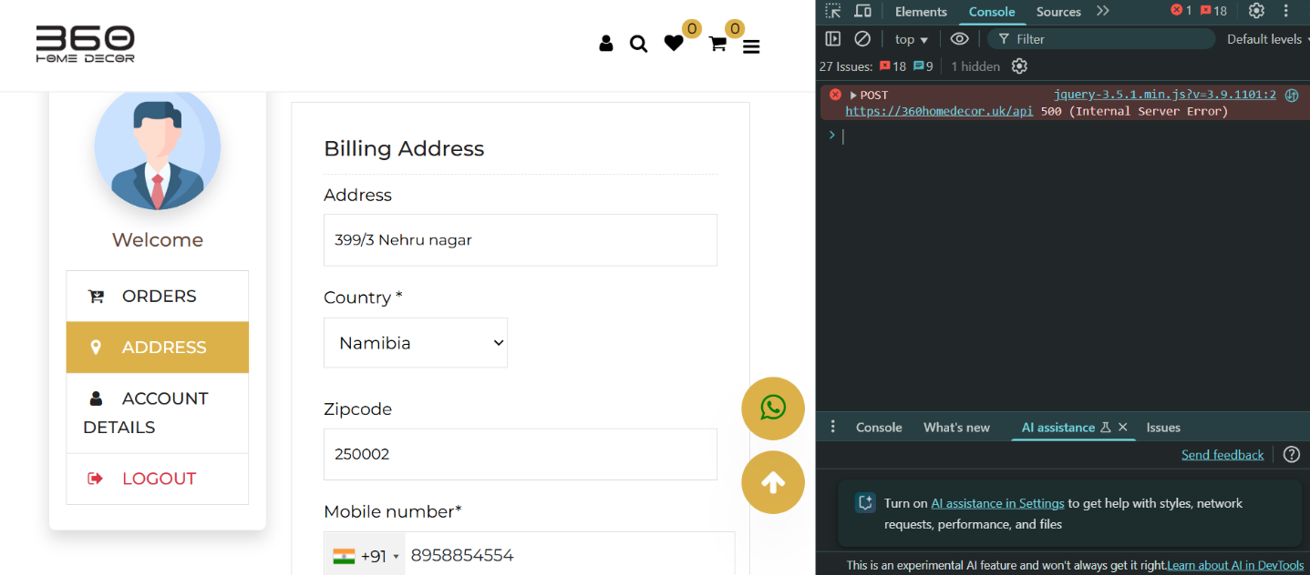

6 . What’s app Bot is not working.

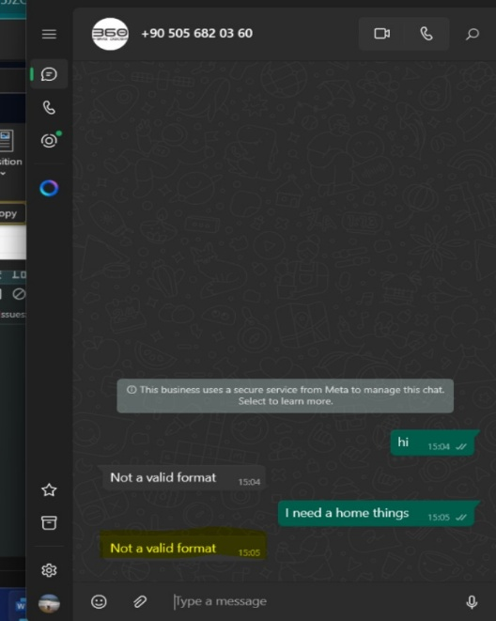

7. After Sign in if , I use search bar and search any think then it function get fail to working.

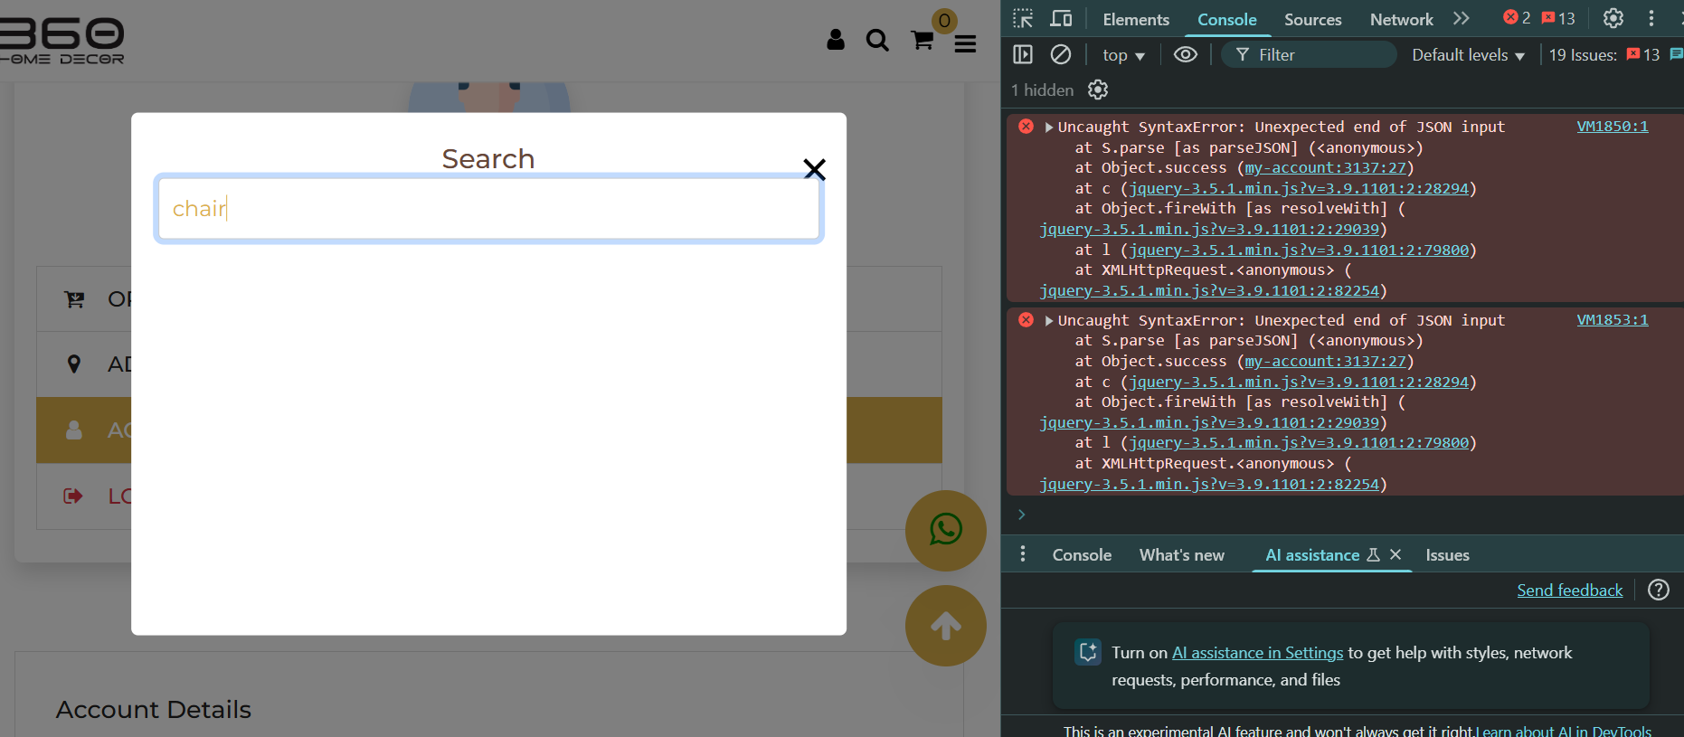

8. On check out page (<https://360homedecor.uk/checkout>) on file checkout comment out the console.log(data) line number 4487. Also it show invalid server response format while click on procced to pay.

